HOW TO SIGN UP FOR EMAILED TAX BILLS

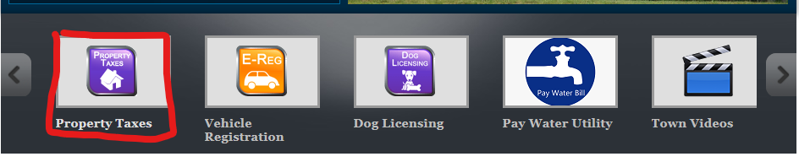
Step 1: Visit the Town of Alton’s website: www.alton.nh.gov

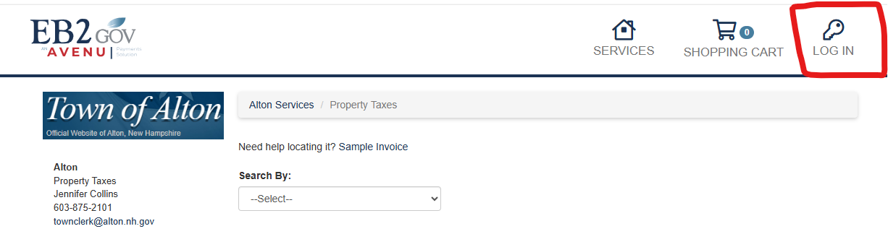
Step 2: Click the key “Log In” button.

Step 3: Sign into your myEB2Gov account or “register”.
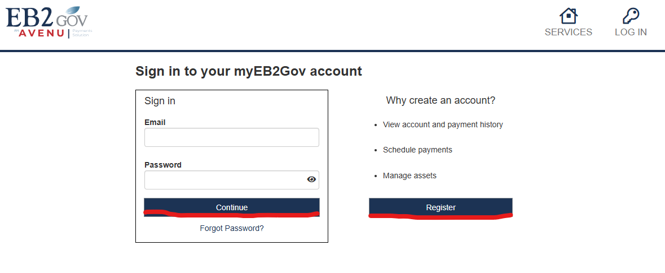

- If registering for the first time, you will need to confirm your email.

Step 4: “Add Assets”. Can search “Auto” or “Manual”. Examples below show manual.
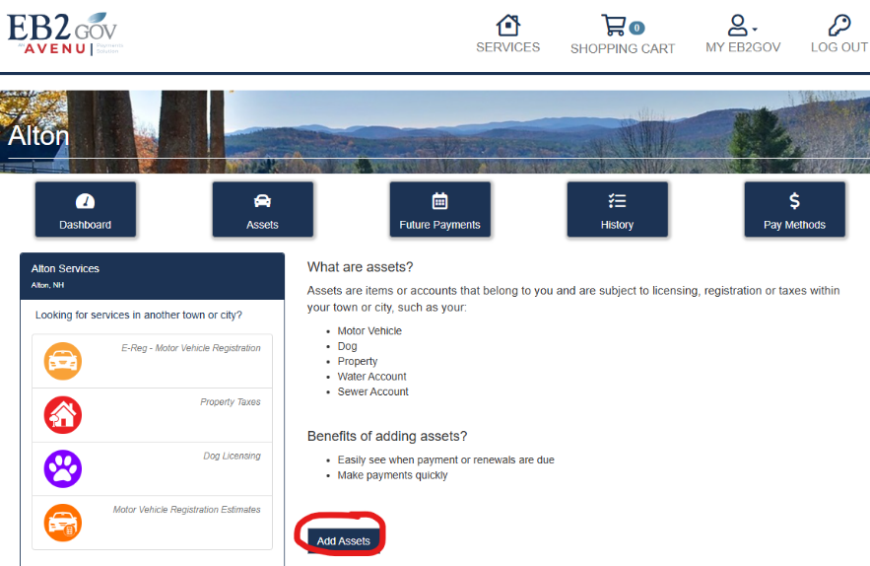

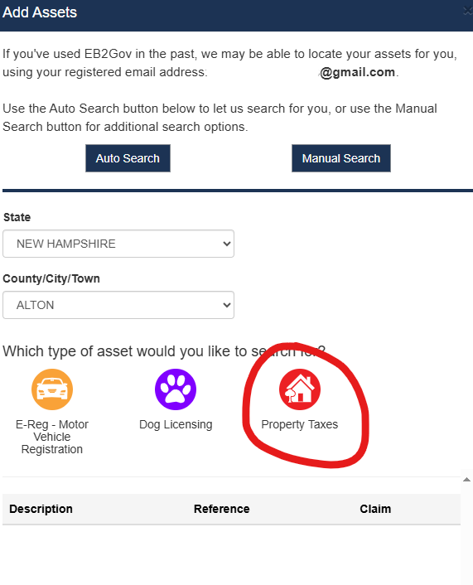

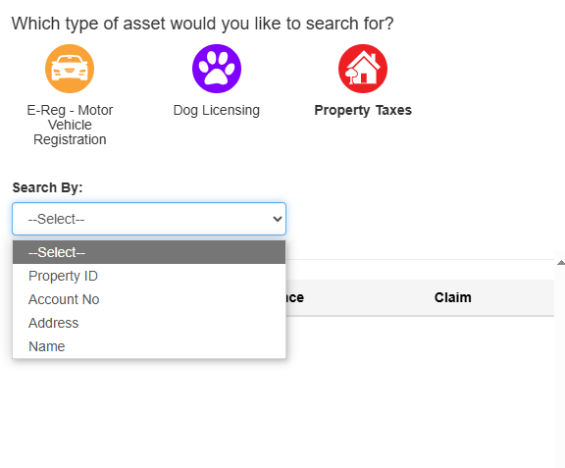

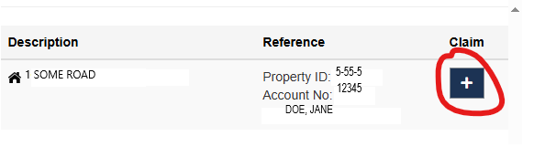
Step 5: When property is found, click the “+” .

